ROCK CLIMBING RULES AND TECHNIQUES

Rock climbing procedures
- Wait in line for your turn
- When you are climbing your partner stays with you (standing and watching you)
- When you are done climbing the wall you BOTH get back in line.
- Your partner now becomes the climber
- Goofing off or not following directions means you will sit and watch for the rest of the day. If it happens again you “may” not be able to climb again and just be a spotter.

Rules for the climber:
- Climb safe
- Give the person in front of you plenty of room to back track
- Do not rush the climber in front of you
- Do not jump off the wall = you are to climb down the wall
- When getting off the wall look to where you’re placing your feet on the mat
- Stay beneath the blue line (hands and head)
- To complete a wall you must touch the non-climbing wall with your HAND only and then put your hand back on the rock wall. Your partner then counts 5 alligators.

Rules for the climbers’ partner (spotter)
- Do not stand on the blue mats
- You are standing and within 10 feet of your parnter
- Make sure your partner stays below the blue line
- Stay in communication w/ Mr. Underwood about your partners climb– ie. My partner is doing wall 1. My partner is starting a wall 2. My partner is halfway through the wall 3. My partner is finishing the wall.
- Make sure your partner is being safe
- Make sure your partner climbs down the wall
- You’re a witness that your partner completed a wall. Count 5 alligators before they climb down

Ideally you will be in a pair (2 people)

If you’re in a group of 3 then ONE PERSON CLIMBS and the
Other two people are the spotters.

What is Bouldering?
Climbing short, challenging problems without a rope on boulders that are low enough to fall from safely.

Benefits of climbing:
Physical benefits: arms, shoulders, legs, neck, back, forearms, hands, cardio.
Psychological/ emotional benefits: Goal setting, body and total awareness, stress relief, confidence, and perseverance.
It’s YOU vs. YOURSELF!

GRADE BREAKDOWN
Bouldering quiz = 20 points
Wall climbing assessment = 40 - 80 points
Participation/effort – climbing and the station workouts – stretching, push up, curl up = 30 points

Wall climbing assessment
Complete Wall 1 = 40 points
Complete Wall 2 = 50 points
Complete Wall 1 & 2 COMBO with no breaks = 60 points
Complete Wall 4 = 70 points
Complete Wall 1, 2, 4 COMBO with no breaks = 80 points
Complete Wall 3 = Extra credit 90 points
Complete Wall 1, 2, 3, 4 COMBO = EXTRA CREDIT = 100 points

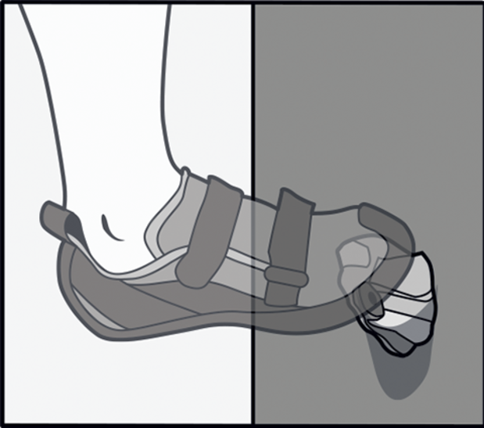 | Edging
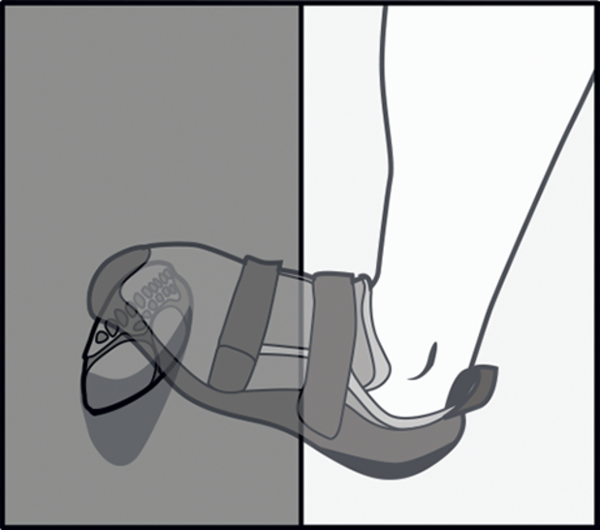 | Toeing
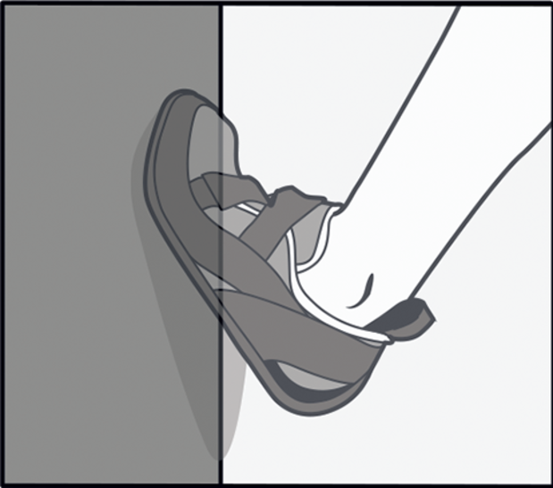 | Smearing
Body placement and 3-points of body contact – move with your feet then follow with your hands. Try to keep your body close to the wall. | Foot, foot, hand  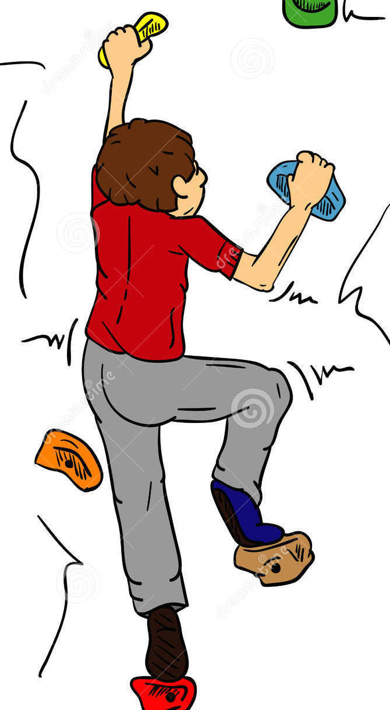
Focus on balance and your center of gravity – ideally head over hips, hips over feet. If you reach with your hand one direction you may have to extend your leg in the opposite direction to keep your center of gravity and balance. | 