NAME: _______________________________________________________________MR. U PER:________ SEAT #:_________
5 Health-Related Components of Fitness Quiz
_______/22 points
In this section use the word bank (and letter associated with the answer) to answer the questions. Place the letter to the right of the picture. (This section is worth a total of 12 points)
1.  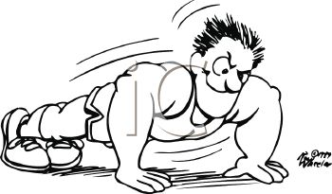 | The 5 Components of Fitness  - Flexibility  - Muscular Strength  - Body Composition  - Cardio-respiratory endurance  - Muscular endurance | 4.
2  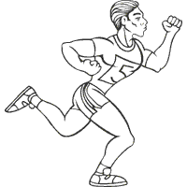 |  | 5.  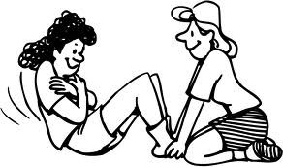
3. |  | 6.  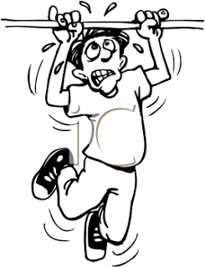

In this section use the word bank (and letter associated with the answer) to answer the questions. (This section is worth a total of 4 points)

7.  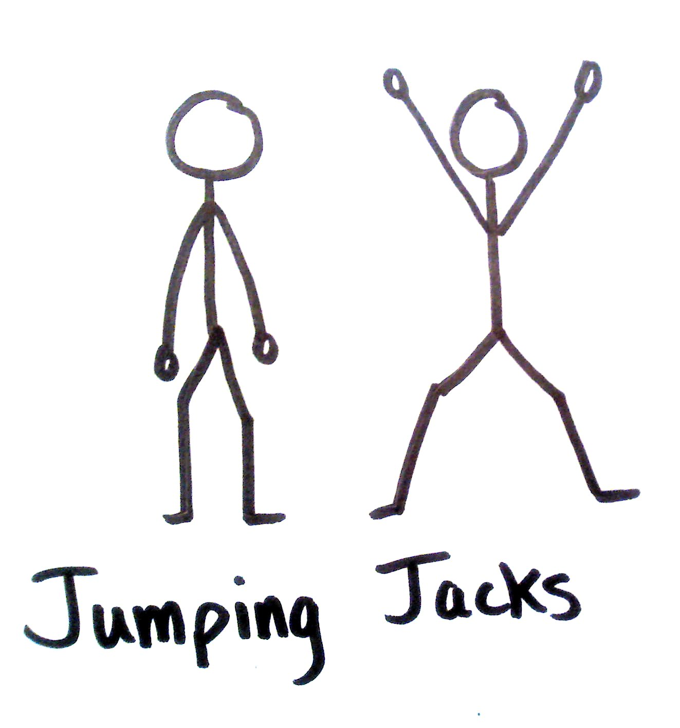 | - Warm up  - Cool down | 8.  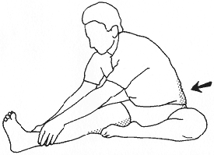

In this section circle the correct answer from the multiple-choice selection beneath each question. (This section is worth a total of 6 points)
9. A soccer player running up and down the field for 40+ minutes is working the _______ component of fitness. A. Cardio-respiratory endurance B. Flexibility C. Muscle strength

10. Warming up allows you to ________ A. get the heart rate up to a workable rate for beginning exercise B. get rid of the lactic acid C. reduce the chances of DOMS D. All of the above

11. Being able to touch your toes while standing is an example of maintaining this component of fitness. A. Cardio-respiratory endurance B. Flexibility C. Muscle strength

5 Health-Related Components of Fitness Quiz DOC

